**Practical 1**

**Aim:** Java - Remote Method Invocation, Communication between Java objects located multiple JVM's.

**Outputs:**

**Server.java:**

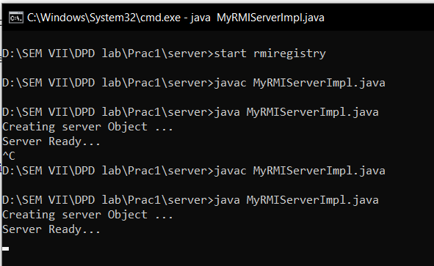

**Client.java:**

